**Experiment 5:** **Signal Operations** & **Synthesis of signals using Fourier Series**

|  |
| --- |
| **Name of the Student : VISHWAS VASUKI GAUTAM** |
| **ID No. : 2019A3PS0443H** |

This experiment is intended to make the student to learn about Signal operations and Fourier Series (FS) of Continuous-time Signals by using MATLAB as a tool for computations. In Run #1, the student understands the time operations on signals. In Run #2, the student is expected to perform FS expansion and obtain the FS coefficients and reconstruct the given piece (non-periodic) of signal from the FS coefficients and the harmonic terms. In Run #3, for given periodic signals, plot the Fourier Spectra (magnitude and phase angle spectra) and also observe the Gibbs phenomenon while reconstructing the signal.

**Run #01: Signal operations**

Q1. (i) Write the expression for the given signal x(t) in your notebook. Write a MATLAB code for this expression using relational / logical operators and plot it

(ii) Perform the given operations on the generated signal x(t) . Plot them, give x,y labels, title, grid on

(i) x(t - 1) (ii) x(2 - t) (iii) x(2t + 1) (iv) x(4 - t/2)

x(t)

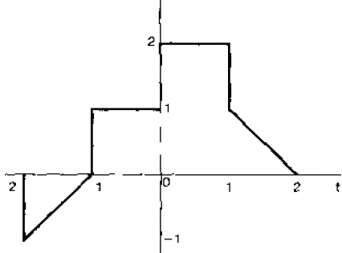

|  |
| --- |
| Answer (paste the written code and plots):  t = (-2:0.1:2)';  x = (t>=-2 & t<=-1).*t + (t>-1 & t<=0).*1 + (t>0 & t<=1).*2 + (t>1 & t<=2).*(-t);    clf  subplot(511)  plot(t,x)  xlabel("t"), ylabel("x(t)"),  title("x(t)"),      t1 = t-1;  x1 = (t1>=-2 & t1<=-1).*t1 + (t1>-1 & t1<=0).*1 + (t1>0 & t1<=1).*2 + (t1>1 & t1<=2).*(-t1);    subplot(512)  plot(t,x1);  xlabel("t"), ylabel("x(t-1)")  title("x(t-1)")      t2 = 2-t;  x2 = (t2>=-2 & t2<=-1).*t2 + (t2>-1 & t2<=0).*1 + (t2>0 & t2<=1).*2 + (t2>1 & t2<=2).*(-t2);    subplot(513)  plot(t,x2);  xlabel("t"), ylabel("x(2-t)")  title("x(2-t)")      t3 = 2*t+1;  x3 = (t3>=-2 & t3<=-1).*t3 + (t3>-1 & t3<=0).*1 + (t3>0 & t3<=1).*2 + (t3>1 & t3<=2).*(-t3);    subplot(514)  plot(t,x3);  xlabel("t"), ylabel("x(2t+1)")  title("x(2t+1)")      t4 = 4-(2*t);  x4 = (t4>=-2 & t4<=-1).*t4 + (t4>-1 & t4<=0).*1 + (t4>0 & t4<=1).*2 + (t4>1 & t4<=2).*(-t4);    subplot(515)  plot(t,x4);  xlabel("t"), ylabel("x(4-2t)")  title("x(4-2t)") |

**Run #02: Fourier Series and reconstruction of a signal**

(2) For the signal ‘f (t)’ shown below

0

5

15

10

20 

3 V

0 V

t (s)

12

1. Write MATLAB code using relational operators and plot the above signal ‘f(t)’ between 0 to 20s
2. Now, obtain the expressions for Trigonometric Fourier series coefficients **a0, an**, and **bn** for the above signal considering the signal of duration from t1= 9 and t2= 13 (Time period, T0 = 4)

**NOTE** : (1) Solve all the integrals and obtain the final expressions for **ao, an** and **bn**

(2) Do all these calculations in your observation book only

(3) Plot the *original signal* and *reconstructed signal* on a single graph only.

Explore **hold on** & **hold off** matlab plot commands

1. Write Matlab code for computing **a0, an**, and **bn** using the expressions you have derived in your observation notebook as a function of **n (**no. of harmonics / no. of terms**) by** using **for loop**
2. Write MATLAB code for reconstructing the signal using **FS coefficients ao, an and bn**. The reconstruction should be limited to the duration t1 = 9 and t2 = 13. (T0 = 4) and no. of harmonics (n) = 5.
3. Consider n (no. of harmonics) = 10 and use the above code to reconstruct the signal during t1= 9 and t2= 13. (T0 = 4). Comment on your observations on how closely the reconstructed signal is following
   1. at the rising and falling edges, b. at the flat portion (3V region) and
4. at the flat portion (0 V region) of the original signal
5. For n = 10, evaluate the reconstructed signal for a time duration t = 0 to 20 (To = 4) and plot. How is this different from original f(t)? Comment on your observation.

|  |
| --- |
| Answer (paste the written code and plots):  t = (0:0.1:20);  x = (t>=10 & t<=12).*3;  clf  plot(t,x)      t = (0:0.01:20);  x = (t>=10 & t<=12).*3;    clf  hold on  plot(t,x)    ft = 1.5;    for n = 1:1:10  bn = (3/(n.*pi)).*(cos(5*pi.*n) - cos(6.*n*pi));  ft = ft + bn*sin(2.*n*pi*t./4);  end    plot(t,ft)    e)  With the number of harmonics = 10  The signal reconstruction along the rising and falling edge is perfect, however, in the 3V and 0V parts it is slightly variable and does not re-construct properly, hence a higher number of harmonics needs to be taken.  f)  The original signal is different from the reconstructed signal in the 3V edge and the 0V edge. It is oscillatory in nature and does not reconstruct the 3V and 0V edge properly. |

**Run #03 : Fourier Series and Fourier Spectra.**

Q3. For the following signal

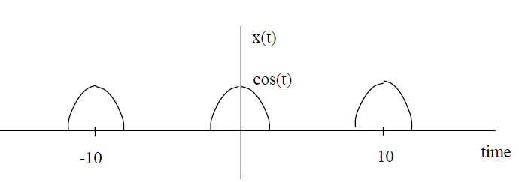

1. Obtain the exponential Fourier series expression between the limits ( - π /2 to + π / 2) for the above signal
2. Find the exponential Fourier series coefficients using matlab program for n = 15
3. Plot the spectra versus frequency (explore ***abs*** and ***angle*** Matlab commands)
4. Generate the original signal from the Fourier components and observe Gibbs Phenomena for n = 10, 20 and 50

|  |
| --- |
| Answer (paste the written code and plots):  a)  ao = 2/pi;  an = (-1/2*pi)*((cos((2*n+1)*pi/2))/(2*n+1) - (cos((2*n-1)*pi/2))/(2*n-1));  bn = 0;  so Dn = an/2 and D0 = a0 for exponential fourier series.  b)  for n = 15  an =  0.0045  c)     1. When n = 10:     When n = 20:    When n = 50:    Code:  t = (-5:0.001:5);  x = cos(t).*(t>=-pi/2 & t<=pi/2);  clf  subplot(211);  plot(t,x)  title("original signal")  ft = 2/pi;  for n = 1:1:50  an = (2/pi)*((sin((2*n+1)*(pi/2)))./(2*n+1) + (sin((2*n-1)*(pi/2)))./(2*n-1));  ft = ft + an*cos(2*n*t);  end  subplot(212);  plot(t,ft, 'r')  title("reconstructed signal") |

**Link to upload files**

**Tuesday Batch https://forms.gle/sCPCiG8tTrEHKqry7**

**Sunday of the week in which you perform this experiment mostly March 21 5 PM**

**Thursday batch Link https://forms.gle/cngagDXrHMZiLXQu9 Due on Feb 28th 5 PM**

**Try Yourself**

Q4. For the following signal

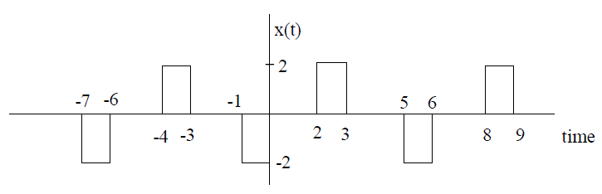

(i) Find the exponential Fourier series coefficients using matlab program for n = 15

(ii) Plot the Magnitude spectra versus frequency

(iii) Generate the original signal from the Fourier components and observe Gibbs Phenomena for n = 10, 20 and 50